A

PROJECT REPORT
ON
TUNE NEST Web Music Player

Submitted in partial fulfillment for the award of

Post Graduate Diploma in Advance Computing

(PG-DAC) from

INSTITUTE OF EMERGING TECHNOLOGIES

Authorized Training Centre


Under the Guidance of
Name of the Guide
BY
Jayashree Derkar(250245920035)
Chetan Thorat(250245920020)
Likesh Chaudhari(2502459200)
Krishna pandit(2502459200)



CERTIFICATE

This is to certify that the project report entitled Tune Nest-Web Music player is a bonfire work carried out by Jayashree Derkar, Chetan Thorat, Likesh Chaudhari, Krishna pandit and submitted in partial fulfilment of the requirement for the C-DAC ACTS, DAC course in Institute of Emerging Technology in the batch of Feb 2025.

Course Coordinator External Examiner

ACKNOWLEDGEMENT

This project Tune Nest-Web Music player was a great learning experience for us and we are submitting this work to Advanced Computing Training School (CDAC).

We are very glad to mention the Name of the Guide for her valuable guidance to work on this project. Her guidance and support helped us to overcome various obstacles and intricacies during the course of project work.

Our most heart full thanks goes to Mr. Sangram Patil (Director ,IET)who gave all the required support and kind coordination to provide all the necessities like required hardware , internet facility and extra lab hours to complete the project and throughout the course up to the last day here in C-DAC ACTS, Pune.

Sign of student
Name of Student/s
Roll no.

Abstract

This project is a full-stack music streaming web application inspired by Spotify, developed using React.js for the frontend, ASP.NET Core Web API for the backend, and MongoDB as the database. It follows a Database-First approach, where the MongoDB collections are designed first to store and retrieve user accounts, playlists, and song metadata efficiently. The backend manages secure authentication using JWT tokens and returns song and playlist data in BSON format, while actual audio files are stored on the server or in cloud storage. The frontend offers an interactive user experience with features such as music search, playback controls, playlist creation, and liking tracks. A payment gateway integration enables users to subscribe to premium plans for ad-free and high-quality streaming. The architecture ensures scalability, data security, and smooth playback, delivering a realistic and user-friendly online music streaming experience.

Index

Sr. No. | Title | Page No.
1 | Introduction
2 | Problem Definition & Scope
2.1 | Problem Definition
2.2 | Goals & Objectives
2.3 | Major Constraints& Outcomes
3 | Software Requirement Specification
3.1 | Purposed System
3.2 | Scope
4 | System Modules
5 | Performance-Requirements
5.1 | H/W Requirements & S/W Requirements
6 | UML Diagram
6.1 | DFD
6.2 | ERD
6.3 | Use case diagram
6.4 | Class Diagram
6.5 | Sequence diagram
6.6 | Activity Diagram
6.7 | Deployment diagram
6.8 | System Architecture
7 | Test Cases
8 | Screenshots
9 | References

- Introduction

Music streaming has become one of the most popular forms of digital entertainment, with platforms like Spotify, Apple Music, and Amazon Music revolutionizing how people access and enjoy music. A music streaming application allows users to instantly play songs from a vast library without the need to download them, providing convenience, personalization, and accessibility.

The Spotify Clone project is developed to simulate the core functionalities of a real-world music streaming platform while showcasing the integration of modern web development technologies. It serves both as an educational project for understanding full-stack development and as a demonstration of implementing a scalable, secure, and interactive web application.

The project is built using React.js for the frontend, ASP.NET Core Web API for the backend, and MongoDB for database management, following a Database-First approach. The application provides essential features such as user authentication, song search, playlist creation, music streaming, and premium subscription management. The backend uses JWT-based authentication to ensure secure user sessions, and all audio files are served from either a dedicated server or cloud storage.

In addition to core music streaming functionalities, the system integrates a payment gateway (Razorpay/Stripe) to enable premium subscriptions, offering enhanced features such as ad-free streaming, high-quality audio, and unlimited skips. This implementation demonstrates the combination of front-end UI/UX design, backend API development, database modeling, and payment integration in a single project.

By replicating real-world music streaming workflows, this project provides a complete understanding of modern web application development and can be extended for further functionalities such as AI-based recommendations, offline playback, or real-time collaborative playlists.

2. Problem Definition and Scope
2.1 Problem Definition
With the rapid growth of online music streaming, users expect instant access to vast music libraries with high-quality audio, personalized recommendations, and seamless playback. Traditional downloading methods require large storage space, lack real-time updates, and limit music accessibility across devices.

Existing streaming platforms such as Spotify, Apple Music, and Amazon Music provide advanced features but have certain drawbacks, including restricted access for free users, regional content limitations, limited playlist customization, and relatively high subscription costs in some markets.

Therefore, there is a need to develop a cost-effective, secure, and scalable music streaming web application that allows users to:

- Stream music directly without downloads.

- Manage playlists efficiently.

- Access premium features via secure online payments.

- Enjoy a responsive and user-friendly interface across devices.

This project aims to address these needs by implementing a full-stack solution using React.js for the frontend, ASP.NET Core Web API for the backend, and MongoDB with a Database-First approach for data management.
2.2 Goals & Objectives

Goals
The primary goal of this project is to design and develop a full-stack music streaming web application that replicates essential functionalities of popular platforms like Spotify, while being customizable, cost-effective, and scalable. The system should provide secure authentication, smooth music playback, and efficient playlist management with an intuitive user interface.

Objectives
- Develop a responsive and user-friendly interface using React.js for seamless navigation and music streaming experience.

- Implement secure authentication and authorization using JWT tokens to protect user accounts and data.

- Integrate MongoDB (Database-First approach) to store and manage user profiles, playlists, and song metadata in BSON format.

- Provide playlist management features including create, update, and delete options for users.

- Enable music streaming through an HTML5 audio player with basic controls like play, pause, skip, and repeat.

- Integrate a payment gateway (e.g., Razorpay or Stripe) for premium subscription features such as ad-free streaming, unlimited skips, and higher audio quality.

- Ensure scalability and maintainability of the system through a well-structured backend using ASP.NET Core Web API.

- Deliver a secure, optimized, and scalable platform that can be enhanced in the future with AI-based recommendations, social features, and offline playback.

2.3 Major Constraints& Outcomes
Major Constraints
- Licensing and Copyright

- Real-world deployment would require music licensing agreements, which are not implemented in this prototype.

- Database Storage

- Limited storage capacity for music files; the current system focuses on metadata storage rather than actual high-quality music hosting.

- Internet Dependency

- Continuous internet connection is required for streaming; no offline playback is implemented.

- Payment Integration Limitations

- Payment gateway (Razorpay/Stripe) is implemented for demonstration purposes and not for actual commercial transactions.

- Geographic and Content Restrictions

- No real-time content filtering or regional restriction features are included.

- Performance on Low-End Devices

- Music playback quality may be affected on devices with lower processing power or poor internet speed.

Expected Outcomes
- Fully Functional Music Streaming Platform

- Users can register, log in, browse songs, create playlists, and stream music seamlessly.

- Secure User Management

- JWT-based authentication ensures data security and privacy.

- Playlist Management System

- Users can add, remove, and manage songs in personalized playlists.

- Payment Gateway Integration

- Premium subscriptions enable ad-free, high-quality music streaming.

- Scalable Architecture

- The system is built using ASP.NET Core Web API and React.js, allowing future enhancements like AI recommendations, lyrics display, and social features.

- Database-First Approach with MongoDB

- Efficient storage and retrieval of music metadata in BSON format.
3. Software Requirement Specification
1. Introduction
1.1 Purpose
The purpose of this project is to develop a full-stack music streaming platform similar to Spotify, where users can register, browse songs, create playlists, and stream music online. Premium users can access ad-free and high-quality streaming through a secure payment system.

1.2 Document Conventions
- MongoDB data format: BSON

- API format: RESTful JSON

- Authentication: JWT tokens

1.3 Intended Audience
- End Users – Music listeners (free and premium)

- Administrators – Manage music library and subscriptions

- Developers – Maintain and upgrade the system

1.4 Scope
The system provides a music streaming service with playlist creation, music browsing, secure user authentication, and subscription-based premium features. Admins can manage songs and user accounts.

2. Overall Description
2.1 Product Perspective
The system consists of three main layers:

- Frontend: React.js for a responsive and interactive UI.

- Backend: ASP.NET Core Web API for business logic and data handling.

- Database: MongoDB (Database-First) for storing user data, song metadata, and playlists.

2.2 Product Features
- User authentication (Login/Register)

- Song search and playback

- Playlist creation and management

- Payment gateway for premium subscriptions

- Admin control for song and user management

2.3 User Classes & Characteristics
- Guest User: Can browse limited songs, needs to register for full access.

- Registered User: Can create playlists, stream songs, and upgrade to premium.

- Admin: Can manage the music library and users.

2.4 Operating Environment
- Frontend: React.js in browser (Chrome, Edge, Firefox)

- Backend: ASP.NET Core Web API hosted on Windows/Linux server

- Database: MongoDB hosted on cloud/local server

3. Functional Requirements
- User Authentication – Users can register, log in, and log out.

- Music Browsing & Search – Search and filter songs by genre, artist, and album.

- Playlist Management – Create, edit, and delete playlists.

- Music Playback – HTML5 audio player integration.

- Subscription & Payment – Secure payment for premium accounts.

- Admin Management – Admin can manage users and songs.

4. Non-Functional Requirements
- Performance: Streaming latency should be under 2 seconds.

- Security: JWT authentication, encrypted payment processing.

- Scalability: Support for thousands of concurrent users.

- Usability: Responsive UI for desktop and mobile.
3.1 Purposed System
The proposed system is a full-stack online music streaming platform designed to replicate and customize the core features of Spotify. It enables users to register, log in, browse a music library, create and manage playlists, stream songs in real-time, and access premium features through an integrated payment gateway.

The system adopts a Database-First approach with MongoDB for efficient storage and retrieval of user profiles, playlist data, and music metadata in BSON format. React.js is used for the frontend to provide a responsive and interactive user experience, while the backend is developed in ASP.NET Core Web API to ensure scalability, security, and maintainability.

The platform offers two modes:

- Free Mode: Users can stream music with limited skips and ads.

- Premium Mode: Users can subscribe via an online payment gateway (e.g., Razorpay/Stripe) to unlock ad-free, high-quality streaming with unlimited skips.

Key Features of the Proposed System
- User Authentication – Secure registration and login using JWT tokens.

- Music Library – Organized collection of songs with search and filter options.

- Playlist Management – Create, edit, and delete playlists.

- Music Streaming – HTML5 audio player with play, pause, skip, and repeat.

- Payment Gateway Integration – Secure subscription purchase for premium features.

- Responsive UI – Seamless experience across devices (desktop, tablet, mobile).
- Scalable Architecture – Easy integration of future features like recommendations and offline mode.

3.2 Scope
The scope of this project is to design and develop a full-stack, database-driven music streaming web application that provides users with a smooth and interactive music listening experience similar to Spotify. The system will be accessible through web browsers and will allow users to create accounts, browse and search songs, manage playlists, stream audio in real-time, and upgrade to premium services via an integrated payment gateway.

The application will adopt a Database-First approach using MongoDB for storing music metadata, playlists, and user data in BSON format. React.js will be used for the frontend to ensure a modern, responsive interface, while the backend will be developed in ASP.NET Core Web API to handle requests, process business logic, and integrate with the database.

The platform will support both Free and Premium user modes:

- Free Mode: Basic music streaming with limited skips and ads.

- Premium Mode: Subscription-based ad-free listening, unlimited skips, and high-quality streaming.

The project aims to serve as a scalable base for future enhancements, such as AI-powered music recommendations, social sharing, offline playback, and multi-language support.

- System Modules
The system is divided into the following major modules:

1. User Authentication & Profile Management
- Handles user registration, login, and logout using JWT-based authentication.

- Stores and manages user details in MongoDB.

- Allows profile updates such as username, password, and subscription status.

2. Music Library Management
- Displays a categorized list of songs with search, filter, and sort features.

- Stores song metadata (title, artist, album, genre, duration) in the database.

- Allows admin to add, update, or delete songs.

3. Playlist Management
- Allows users to create, edit, and delete personal playlists.

- Add or remove songs from playlists.

- Stores playlist information in MongoDB with user references.

4. Music Streaming Module
- HTML5 audio player integration for real-time music playback.

- Provides basic controls: play, pause, skip, repeat, shuffle.

- Streams songs from the backend to the frontend.

5. Payment & Subscription Module
- Integrates payment gateway (e.g., Razorpay, Stripe) for premium subscriptions.

- Upgrades user account to premium after successful payment.

- Handles subscription validity and renewal reminders.

6. Admin Panel Module
- Admin can manage the entire music library and user accounts.

- View subscription reports and payment logs.

- Monitor and manage system performance.
- Performance-Requirements
- High Availability & Scalability:
The system must handle multiple concurrent users streaming songs without lag.
- Low Latency Streaming:
Audio playback should start within 1–2 seconds of a user’s request.
- Efficient Data Handling:
The MongoDB database should retrieve music metadata and playlists in under 200ms for an average load.
- Secure Transactions:
Payment gateway integration must ensure encrypted, error-free transactions.
- Responsive UI:
The React frontend must load within 3 seconds on standard broadband.
- Fault Tolerance:
The system should be able to recover from backend or network interruptions without data loss.
5.1 H/W Requirements & S/W Requirements
Hardware Requirements
For Development Environment
- Processor: Intel i5 (or higher)
- RAM: Minimum 8 GB
- Storage: Minimum 500 GB HDD or 256 GB SSD
- Graphics: Integrated or dedicated GPU for frontend rendering
- Display: 1080p resolution or higher
For Deployment Server
- Processor: Intel Xeon / AMD EPYC (or equivalent)
- RAM: Minimum 16 GB
- Storage: 1 TB SSD (for fast music file access)
- Network: Minimum 1 Gbps bandwidth for handling multiple streams
- Operating System: Windows Server 2019 / Linux Ubuntu Server 22.04

Software Requirements
- Frontend: React.js, HTML5, CSS3, JavaScript (ES6+)
- Backend: ASP.NET Core Web API
- Database: MongoDB (Database-First Approach)
- Payment Gateway: Razorpay / Stripe API
- Audio Streaming: HTML5 Audio API
- Authentication: JWT (JSON Web Token)
- Server OS: Windows Server / Linux Ubuntu
IDE & Tools:
- Visual Studio 2022 (for .NET backend)
- Visual Studio Code (for React frontend)
- MongoDB Compass (Database management)
- Postman (API testing)
Version Control: Git & GitHub
Package Manager: npm (for frontend dependencies)

6. UML Diagram
6.1 Data Flow Diagram
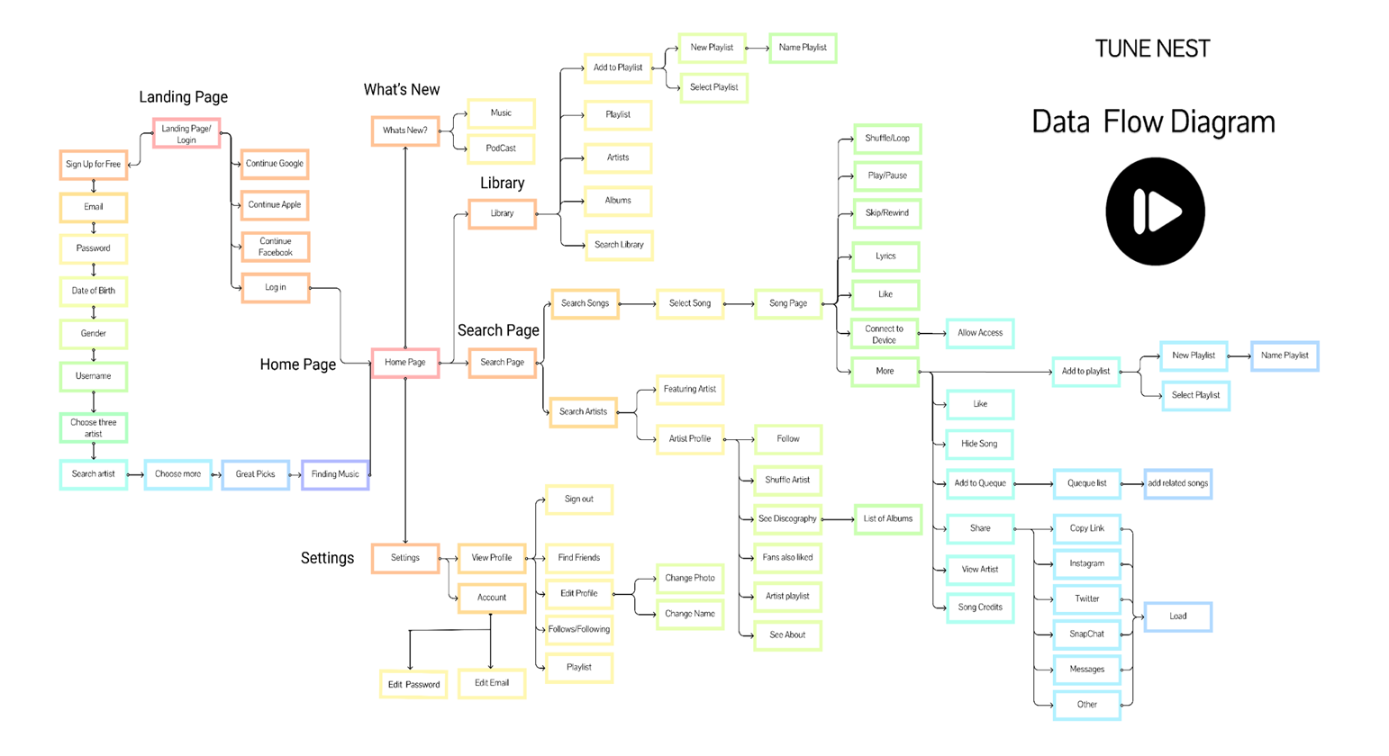
6.2 Entity Relationship Diagram
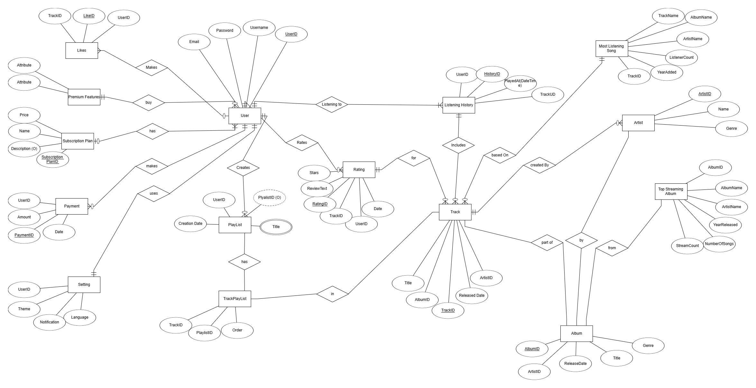
6.3 Use Case Diagram
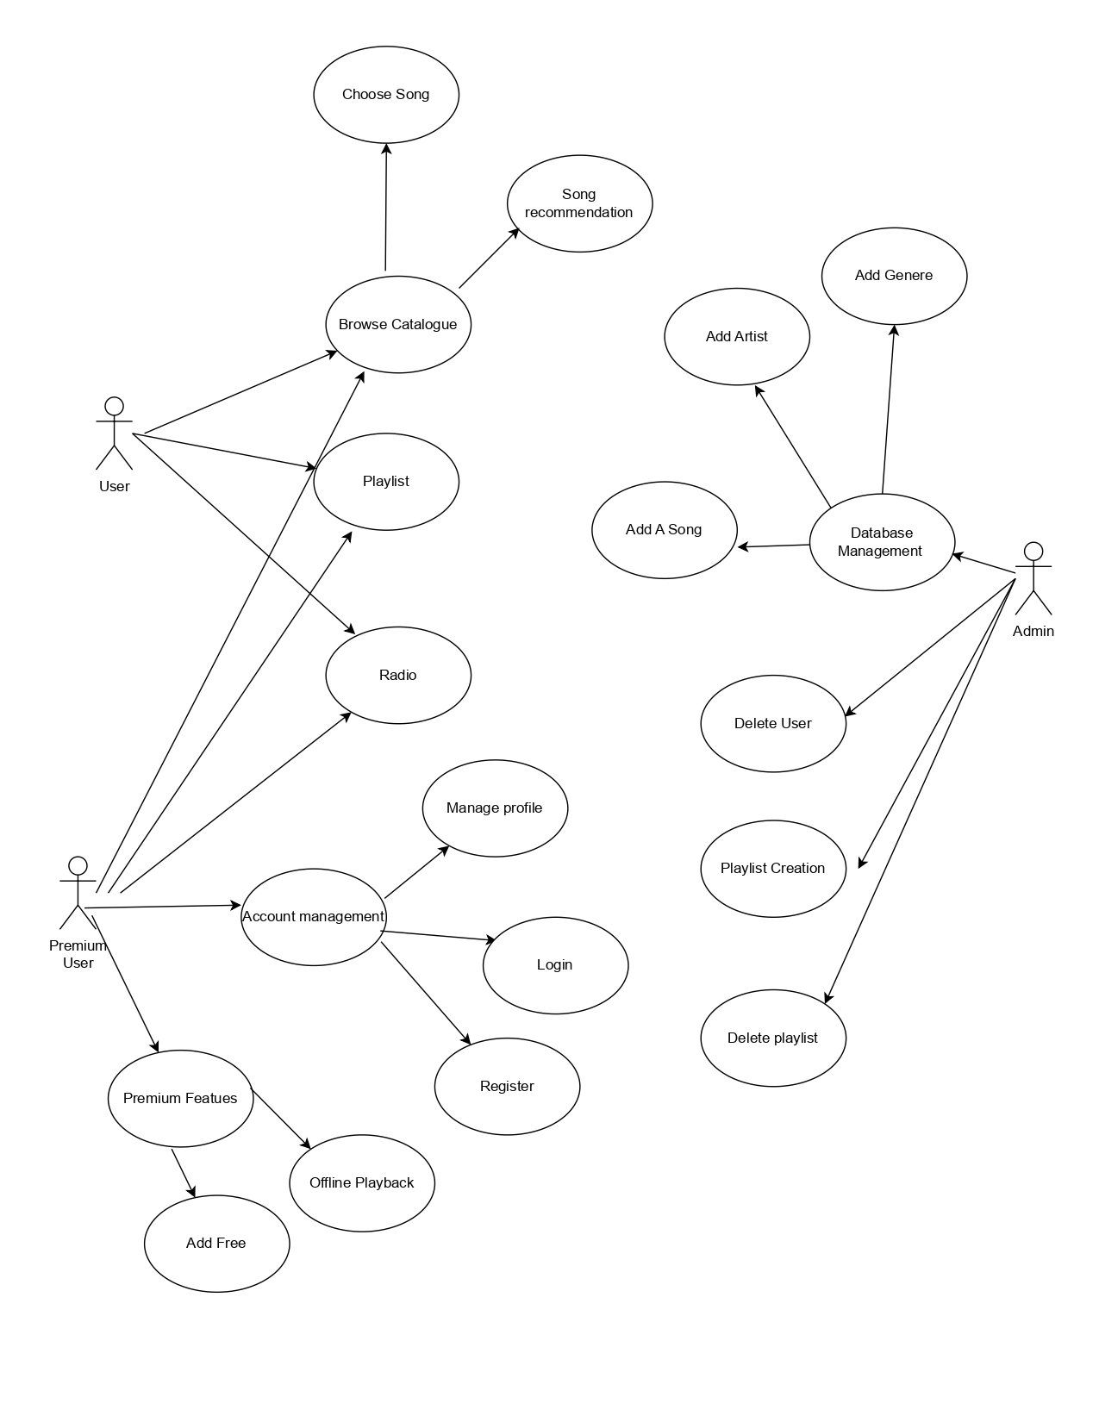
6.4 Class Diagram
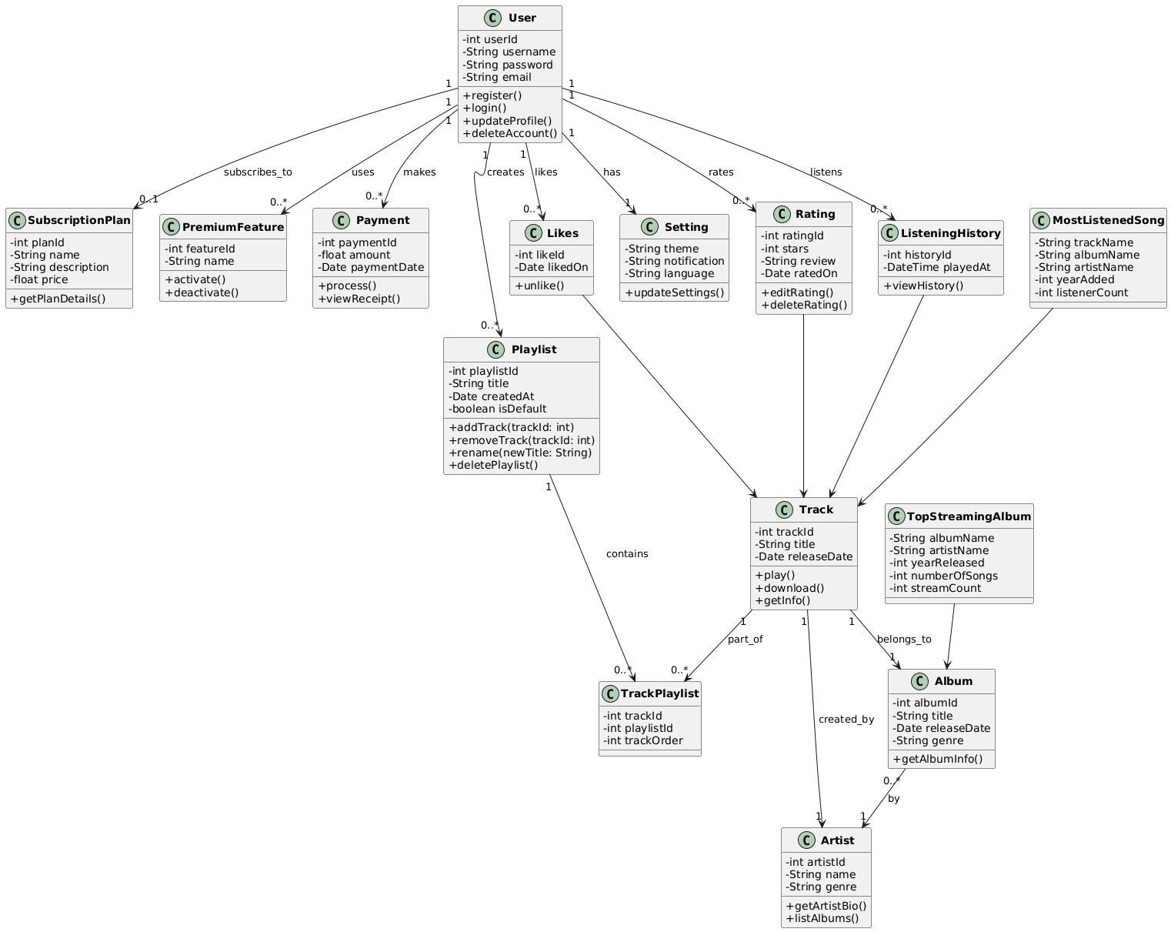
6.5 Sequence Diagram
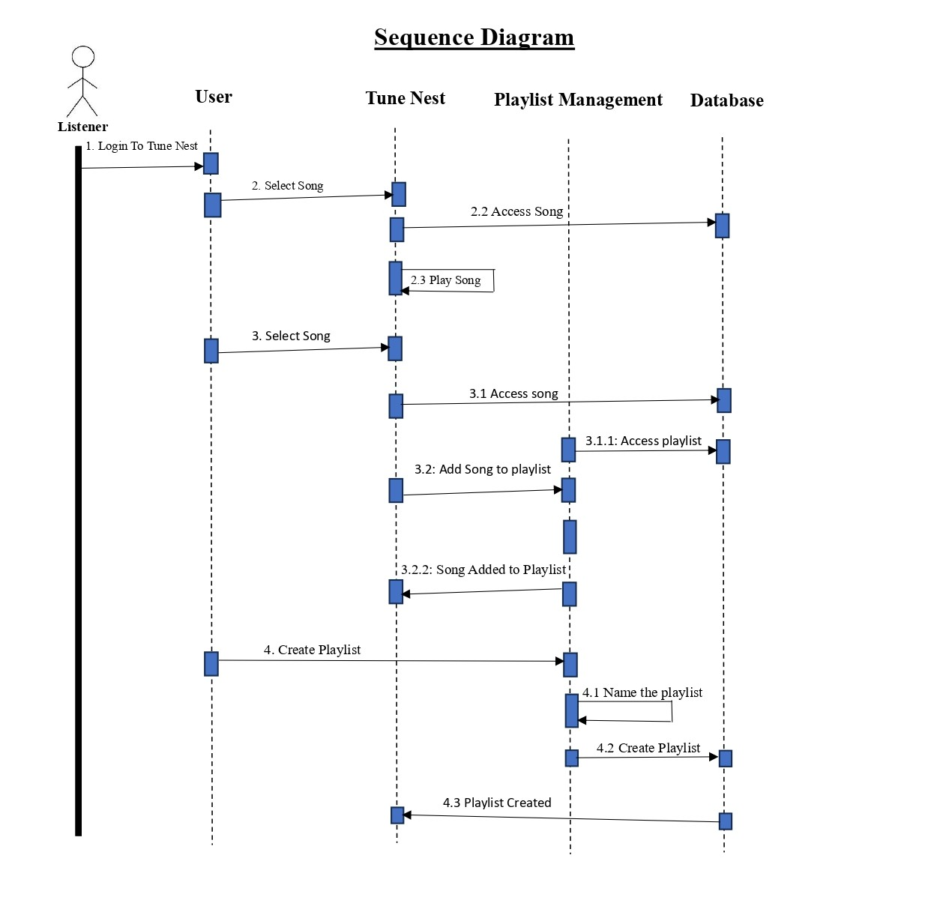
6.6 Activity Diagram
6.7 Deployment diagram
6.8 System Architecture
7. Test Cases

8. Screenshots
9. References

